Missing values method with WEKA

Experimental Procedure
In this experiment I first load the dataset into WEKA tool using preprocessing panel.
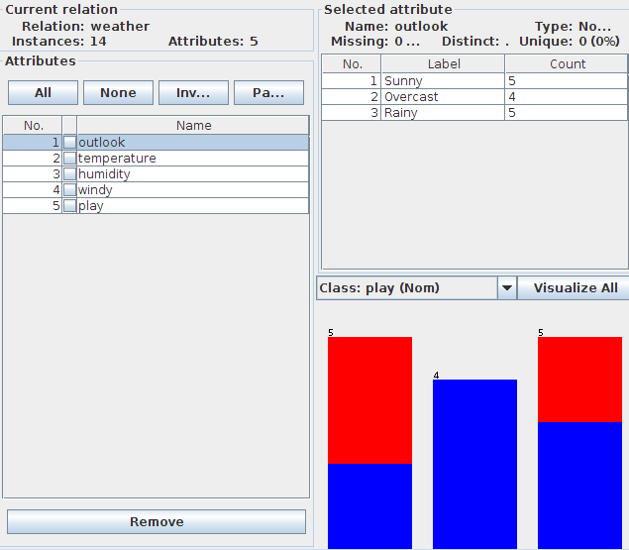

On this dataset I apply filtering algorithm for litwise deletion. Then, in the classify panel we choose C4.5 Decision three classifier and start the analysis using 10 fold cross validation.
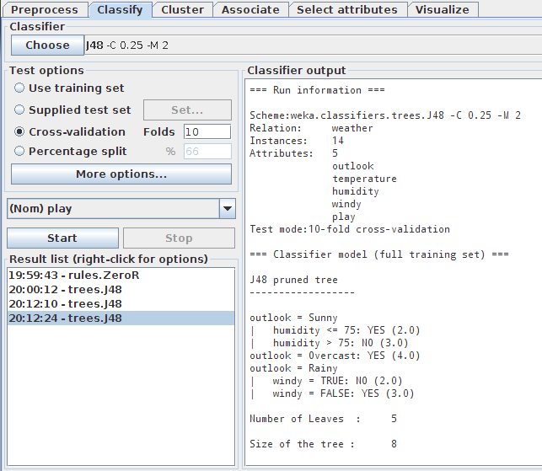

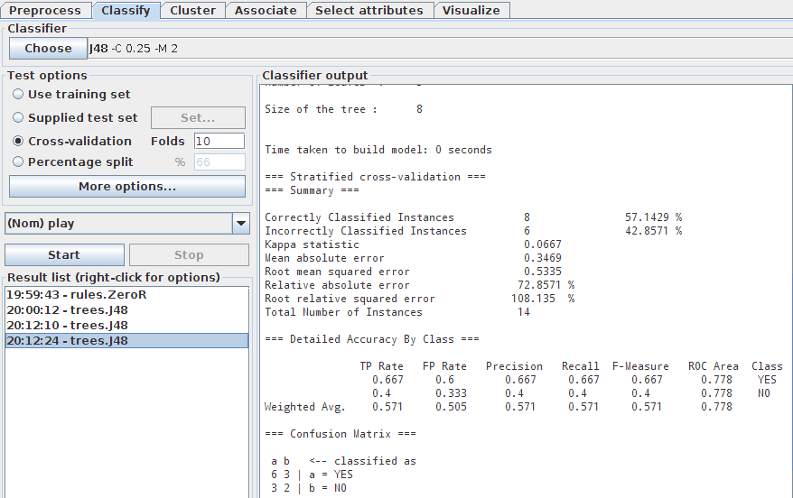
Next, I apply unsupervised filtering technique by choosing replacemissingvalues option. Then, in the classify panel I chose C4.5 Decision tree classifier and start the analysis using 10 fold cross validation.
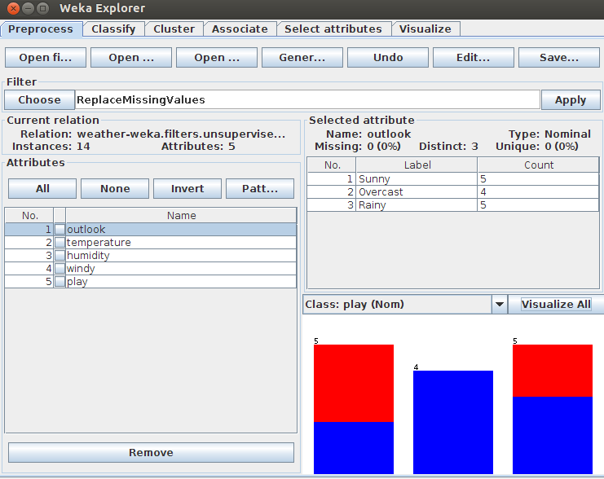

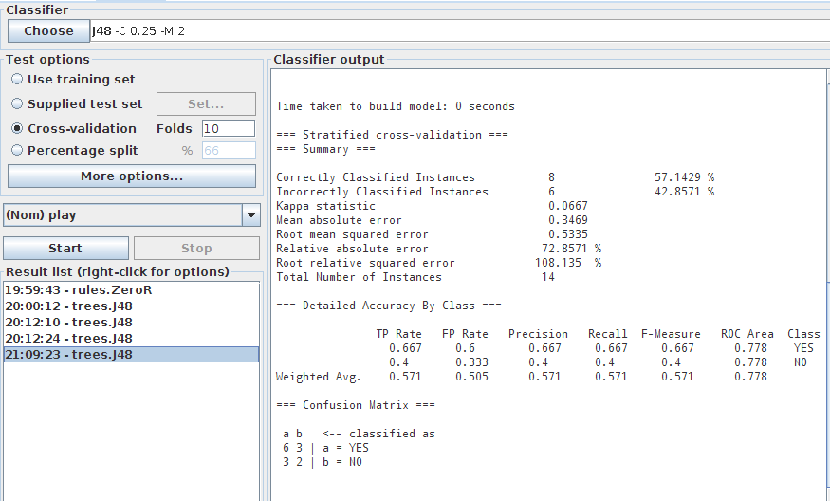

Next step is to apply KNN computation on the dataset. Then, in the classify panel we choose C4.5 Decision tree classifier and start the analysis using 10 fold cross validation.
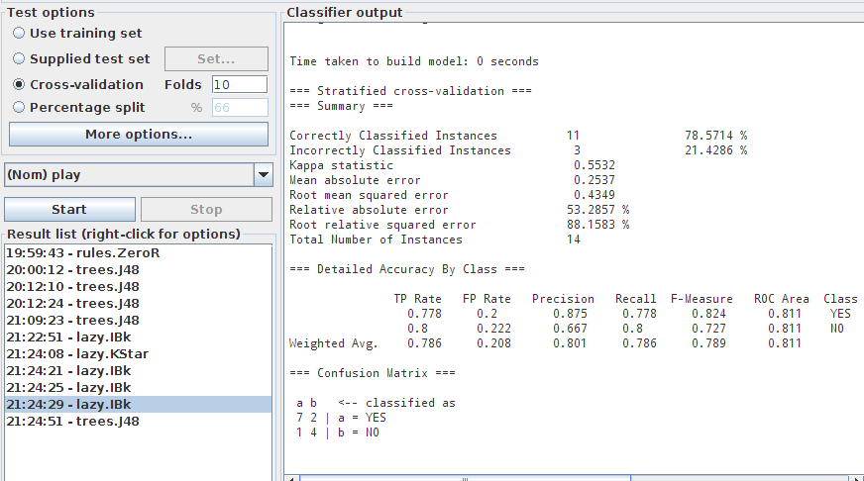

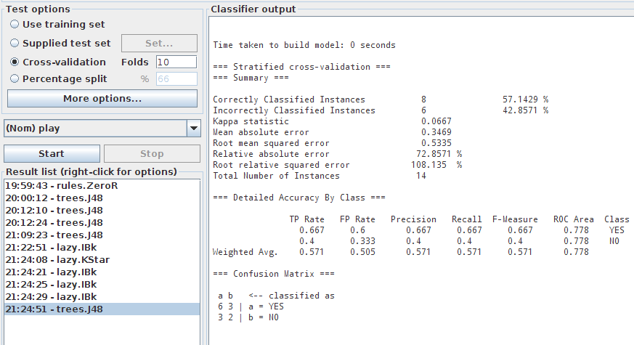

In this assignment the comparison has been done on the basis of accuracy/correctly classified instance and confusion matrix.

Predicted Classes
Actual Classes | TP | FP
 | FN | TN
P N

True Positive(TP) – These are the positive tuples that were correctly labeled by the classifier.
True Negative(TN) – These are the negative tuples that were correctly labeled by the classifier.
False Positive(FP) – These are negative tuples that were incorrectly labeled as positive
False Negative(FN) – These are the positive tuples that were mislabeled as negative

Accuracy: This is based on the probability that the test yields correct results, and it is calculated as = (TP+TN)/(P+N) where, P=TP+FN and N=FP+TN

Algorithm used C4.5 classifier | Correctly classified instances | Incorrectly classified instances | Accuracy | Mean absolute error
Litwise deletion | 8 | 6 | 57.1429 | 0.3469
Mean/mode imputation | 8 | 6 | 57.1429 | 0.3469
KNN(K-nearest neighbor) imputation | 11 | 3 | 78.5714 | 0.5532
According to experimental results, correctly classified instances for Litwise deletion is about 57 and for mean/mode imputation is about 57 too. Correctly classified instances for KNN imputation is about 78, which is greater than previous two algorithms. Accuracy of KNN is 78.5714% which is also greater than other two techniques so KNN is a best technique use for missing data imputation as compared to other two techniques.
.
CONCLUSION
Missing values are regarded as serious problem in most of the information system due to unavailability of data and must be impute before the dataset is used. Here the a weather dataset with missing temperature and humidity values is being used. To handle these missing values three techniques are used named as Litwise deletion, mean/mode imputation, KNN (k nearest neighbor). Firstly dataset is loaded into weka tool. Apply these missing techniques individually on this dataset, which results as three imputed datasets. Then C4.5/J48 classification algorithm is applied to these replaced datasets and their results are compared in order to evaluate the efficiency and accuracy of missing data techniques on the basis of experimental results accuracy and KNN is greater than other two techniques. So, KNN imputation is a better way of handling missing values.

